Project Development Phase
Model Performance Test

Date | 26 June 2026
Team ID
Project Name | Sports Hall Booking System By servicenow
Maximum Marks

Model Performance Testing:
Project team shall fill the following information in model performance testing template.
S.No. | Parameter | Values | Screenshot
 | System Summary | Sports Hall Booking System developed using the ServiceNow Service Portal for online sports venue reservation. The system allows users to browse available sports, select a venue, choose a booking date and time, view pricing details, and complete bookings through a user-friendly interface.  Note: The system validates slot availability before confirming the booking. If a selected slot is already reserved, an appropriate message is displayed to prevent duplicate bookings. | 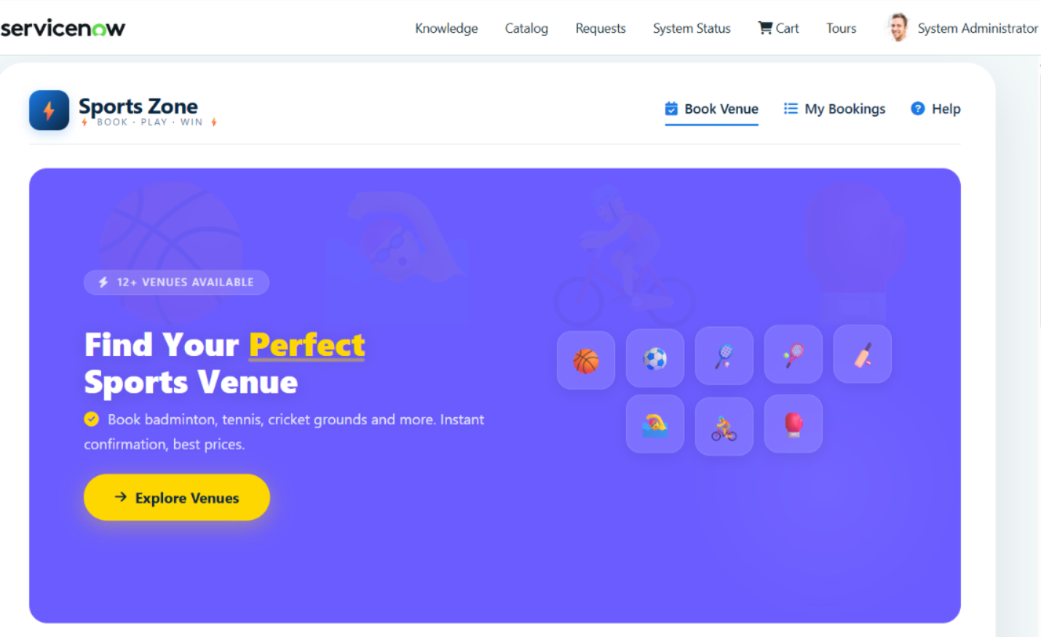
 | System Accuracy | Sports Selection Accuracy: 100%  Venue & Pricing Accuracy: 100%  Booking Information Accuracy: 100%  Payment Details Accuracy: 100%  Overall Functional Accuracy: Successfully validated. | - 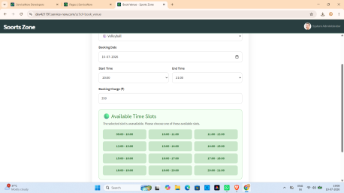
3. | System Validation Result | Booking Confirmation: Booking submitted successfully for valid requests.  Data Validation: Selected sport, venue, date, and time are correctly processed.  Duplicate Booking Prevention: Successfully prevents duplicate reservations.  Overall System Reliability: Functional testing completed successfully with expected results. | 

